|  |
| --- |
| RADIO NIGERA  SUNSHINE FM 88.1MHZ POTISKUM YOBE STATE  Uplifting The People And Uniting The Nation |

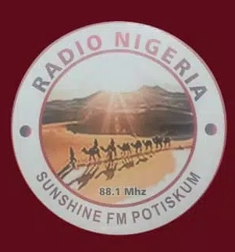

Date:

……………………………………………………

…………………………………………………….

…………………………………………………….

……………………………………………………

Dear Sir,

RE: INDUSTRIAL ATTACHMENT

Reference to your letter dated …………………………………………………….on the above subject matter ,

I am directed to inform you that ………………………………………………….................................................

Of …………………………………………………………………………………….. with registration number………………..

From our institution has been accepted for his/her……………………………………………………………………

Industrial training with this station, please.

Thank you

Ibrahim Ahmed Rufai

SAO

For General Manager